23CSE202 DATABASE MANAGEMENT SYSTEMS
S3 B.Tech CSE
Department of Computer Science and Engineering
Amrita School of Computing, Amritapuri Campus

3. Database Design Document

Group No : C7
Team Members:
Roll No | Student Name
AM.SC.U4CSE25243 | Rajiv A R
AM.SC.U4CSE25249 | Shreyas Rajesh Nair
AM.SC.U4CSE25252 | Sreerag TC
AM.SC.U4CSE25206 | Aryan Rajesh

Project Title : Event Management System
3.1. Detailed description of the project
The Event Management System (EMS) is a centralized web application built to manage the creation, discovery, registration and post-event reporting of institutional events such as workshops, seminars and cultural programs. The system replaces fragmented paper/Google-Form based registration with a single relational database that enforces seat limits, prevents duplicate registrations, and derives live statistics instead of storing them redundantly.
Entities and attributes
- Users (user_id, name, email, role, password) - a single entity represents both stakeholder types (Students and Organizers/Admins), distinguished by the role attribute (role ∈ {student, organizer}). Students and organizers are modelled as one entity type because they share the same identity attributes (name, email, password) and differ only in the permissions and dashboard route enforced by the UI . Email is declared UNIQUE and therefore forms an alternate (candidate) key alongside user_id.
- Events (event_id, name, description, category, date, time, venue, total_seats) : describes an institutional event with a fixed seat capacity, browsed by students on the discovery dashboard and managed by admin.
- Registrations (student_id, event_id, registration_time) : the relation produced by translating the many-to-many Registers relationship between Users (students) and Events into the standard relational form; registration_time is the descriptive attribute of that relationship.
- Notifications (notification_id, student_id, message, clear_date) : a reminder queued for a student ahead of an event they are registered for, as required by the abstract’s “automated reminder” feature.

Relationships
- Registers (M:N, User <-> Event) : a student can register for many events and an event can have many student registrants. Participation is partial on both sides, a student need not register for anything and a freshly created event may have zero registrants. The relationship is guarded by a capacity business rule and carries the descriptive attribute registration_time.
- Receives (1:N, User <-> Notification) : one student receives many notifications, but each notification is addressed to exactly one student. Total, mandatory participation on the User side and partial participation on the Notification side.
Users of the system
- Student — logs in with a college ID, browses events, registers or cancels registration, and views “My Events” with upcoming/past tabs.
- Organizer / Admin — logs in to an administrative dashboard, performs full CRUD on events, monitors live registration counts, and exports participant lists for event-day verification.
Business rules
- A user is either a student or an organizer, never both, enforced by a CHECK constraint on role; only organizers may create/update/delete events, and only students may register/cancel, enforced at the application layer.
- Duplicate registration for the same event by the same student is structurally impossible, since (student_id, event_id) is the composite primary key of Registrations.
- A registration is rejected outright once the number of existing registrants reaches total_seats for that event; this is enforced by the enforce_event_capacity BEFORE INSERT trigger, giving ACID-compliant protection against race conditions when many students attempt to register for the last seat at the same instant.
- An event’s remaining capacity and open/closed status are never stored as columns; they are always derived on demand from Events and Registrations through Event_Status_View, so the seat count can never drift out of sync with the actual registration rows.
- Cancelling a registration is a physical delete from Registrations, which immediately frees a seat because available_seats is recomputed live by the view.
- Deleting a User or an Event cascades to its dependent Registrations and Notifications (ON DELETE CASCADE), so the database never retains unwanted data.
- A reminder Notification is generated for a student one day before every event they are registered for; clear_date marks when that reminder should be removed from the database so as to save storage.
- Scope is confined to academic/institutional events and excludes a payment gateway; consequently Events carries no price attribute and no per-event organizer-ownership column; any organizer account may manage any event (a shared-admin-pool model), which keeps the schema minimal for the stated project scope.

3.2. ER Diagram
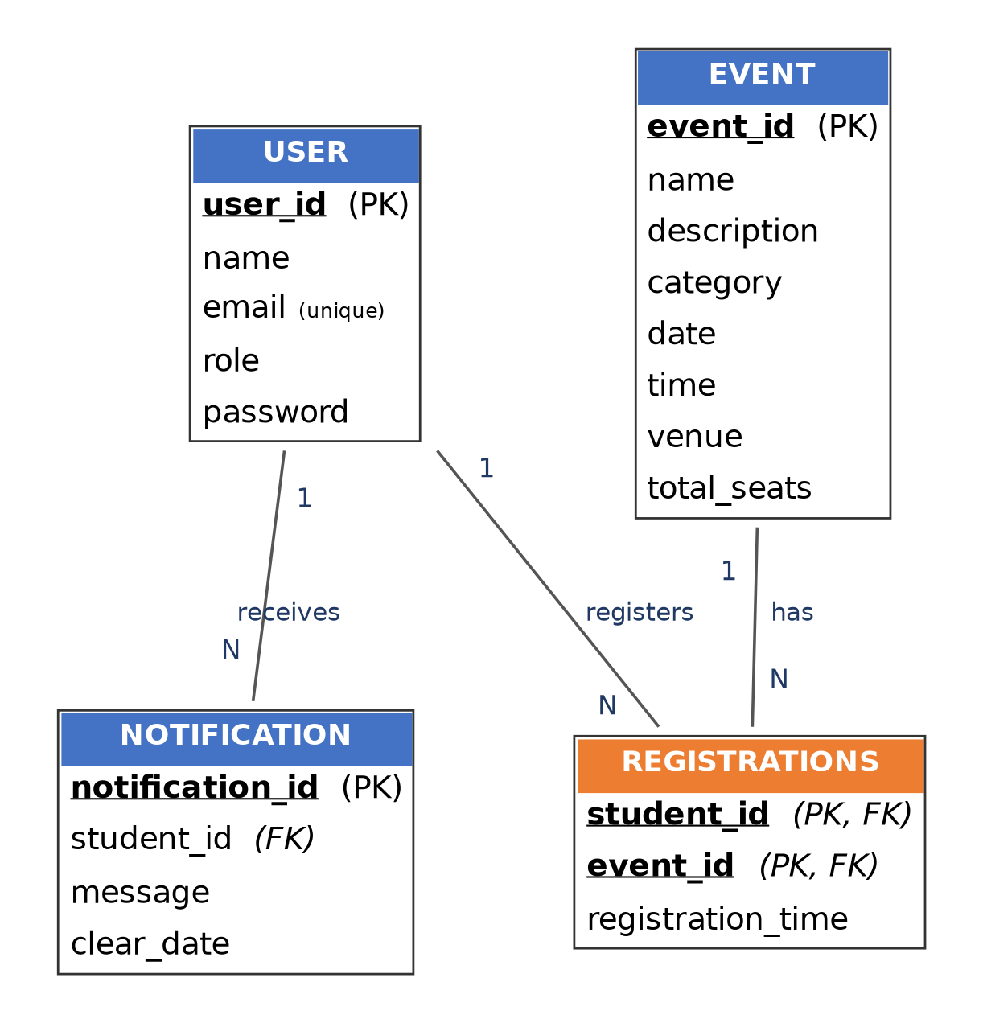
3.3. Relational Schema
Users (user_id, name, email, role, password)
Events (event_id, name, description, category, date, time, venue, total_seats)
Registrations (student_id, event_id, registration_time)
Notifications (notification_id, student_id, message, clear_date)

Relation | Attributes | Key | Foreign Keys / Constraints
Users | user_id, name, email, role, password | PK: user_id | email UNIQUE (alt. key); role ∈ {student, organizer}
Events | event_id, name, description, category, date, time, venue, total_seats | PK: event_id | — (no FK)
Registrations | student_id, event_id, registration_time | PK: (student_id, event_id) | student_id → Users(user_id) ON DELETE CASCADE; event_id → Events(event_id) ON DELETE CASCADE
Notifications | notification_id, student_id, message, clear_date | PK: notification_id | student_id → Users(user_id) ON DELETE CASCADE

Derived / virtual relation (not part of the base schema)
Event_Status_View(event_id, name, category, date, time, venue, total_seats, total_registered, available_seats, isRegistrationClosed) is a view, computed at query time via a LEFT JOIN of Events with Registrations followed by a GROUP BY on event_id. total_registered, available_seats and isRegistrationClosed are all derivable attributes and are therefore deliberately excluded from the stored Events relation — storing them would introduce a transitive dependency on a non-key value (a count of rows in another table) and a classic update anomaly. This design choice is justified further in Section 3.4.
3.4. Normalization and Functional Dependency Analysis
Users (user_id, name, email, role, password)
Functional dependencies:
F1: user_id → name, email, role, password
F2: email → user_id, name, role, password (email is declared UNIQUE)
Attribute closure / candidate keys:
- {user_id}⁺ = {user_id} ∪ {name, email, role, password} (by F1) = all attributes → user_id is a candidate key.
- {email}⁺ = {email} ∪ {user_id, name, role, password} (by F2) = all attributes → email is also a candidate key.
- Both keys are single attributes, so each is trivially minimal. user_id is chosen as the primary key because it is referenced by Registrations and Notifications; email remains an alternate key enforced by the UNIQUE constraint.
Normal form: 1NF holds (every attribute is atomic and single-valued). 2NF holds since the primary key is a single attribute, so no non-prime attribute can be partially dependent on it. 3NF/BCNF hold because every non-trivial FD (F1, F2) has a candidate key on its left-hand side and there is no transitive dependency of one non-key attribute on another — Users is in BCNF.
Events (event_id, name, description, category, date, time, venue, total_seats)
F1: event_id → name, description, category, date, time, venue, total_seats
- {event_id}⁺ = all attributes of Events → event_id is the (only) candidate key, and it is minimal since it is a single attribute.
Normal form: 1NF holds (atomic attributes). 2NF holds (single-attribute key — no partial dependency is possible). 3NF/BCNF hold since the only determinant, event_id, is a candidate key and no non-key attribute determines another — Events is in BCNF.
Registrations (student_id, event_id, registration_time)
F1: (student_id, event_id) → registration_time
Attribute closure of the composite key:
- X = {student_id, event_id}. Applying F1 adds registration_time, giving X⁺ = {student_id, event_id, registration_time} = all attributes of Registrations → the pair is a superkey.
- Minimality: {student_id}⁺ = {student_id} (no FD has student_id alone on the left), and {event_id}⁺ = {event_id}; neither proper subset determines registration_time, so {student_id, event_id} is minimal → it is the (only) candidate key.
Normal form: 1NF holds. 2NF holds because the single non-key attribute, registration_time, depends on the whole composite key and not on either student_id or event_id alone (no partial dependency). 3NF/BCNF hold trivially since there is only one non-key attribute and hence no possibility of a transitive dependency — Registrations is in BCNF.
Notifications (notification_id, student_id, message, clear_date)
F1: notification_id → student_id, message, clear_date
- {notification_id}⁺ = all attributes of Notifications → notification_id is the (only, minimal) candidate key.
Normal form: 1NF holds. 2NF holds since single-attribute key. 3NF/BCNF hold because student_id, message and clear_date each depend directly on notification_id and not transitively on one another (e.g. message does not determine clear_date) — Notifications is in BCNF.

